Volunteers Need Breaks Too!
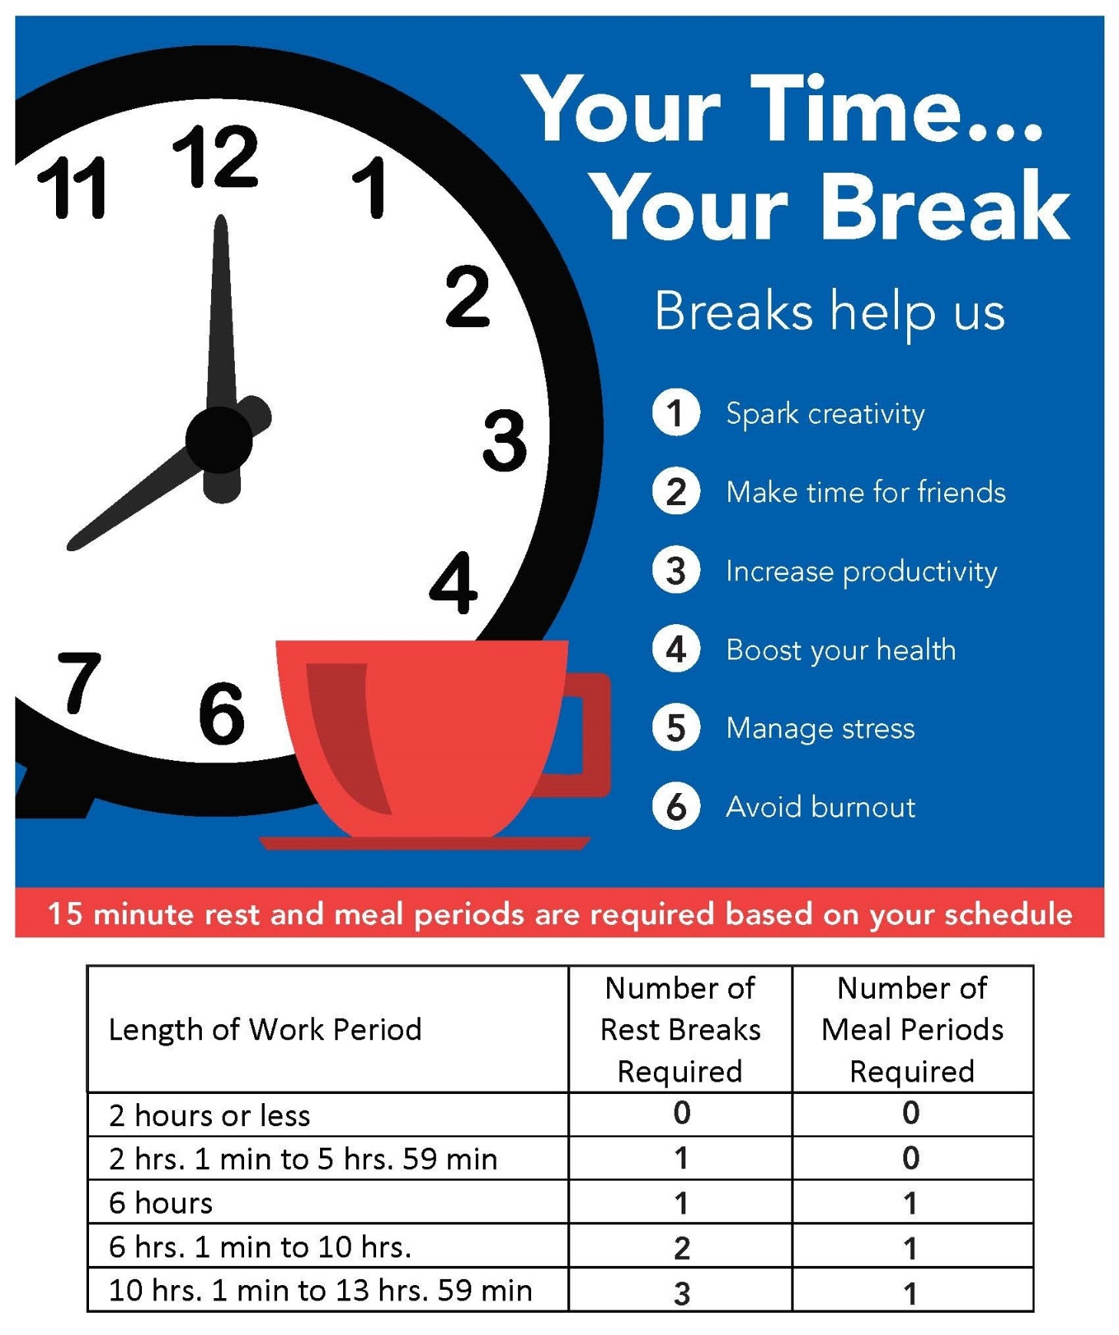
You're entitled to a 15-minute rest period for every 4 hours of work, and a 45-minute meal period for every 6 hours of work.

