Know Your Rights!

Anti-Harassment & Anti-Discrimination Policy

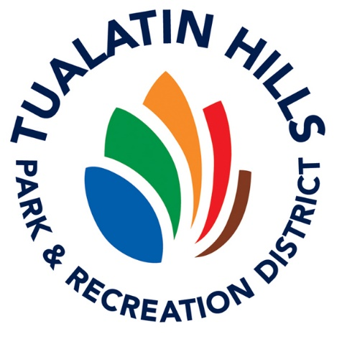

Volunteers **are protected** from harassment and discrimination and

**are prohibited** from harassing

and discriminating against others.

All THPRD employees and volunteers are responsible for creating a workplace that is free of violence and harassment.

**Harassing and discriminatory conduct** includesbut isn’t limited to:

* + Unwelcome physical contact;
  + Insults or comments;
  + Threatening or intimidating acts;
  + Jokes; and/or
  + Written or graphic material

based on gender, gender identity, race, ethnicity, national origin, age, ability level, or any other protected characteristic.

**Sexual harassment** includes but isn’t limited to:

* + Unwelcome physical contact;
  + Threats or offers in exchange for sexual contact;
  + Obscene comments or innuendo; and/or
  + Gestures & eye contact.

**If you experience or observe harassment, discrimination, or retaliation, tell someone!**

* Your supervisor
* Any THPRD supervisor
* THPRD’s Volunteer Services team
  + Incident report form at <http://www.thprd.org/connect/volunteer>
* THPRD’s Human Resources team at [humanresources@thprd.org](mailto:humanresources@thprd.org) or (503) 614-1200

Your report will be investigated, and action will be taken to prevent harassment or discrimination in the future.

Thank you for helping keep THPRD a great place to volunteer!