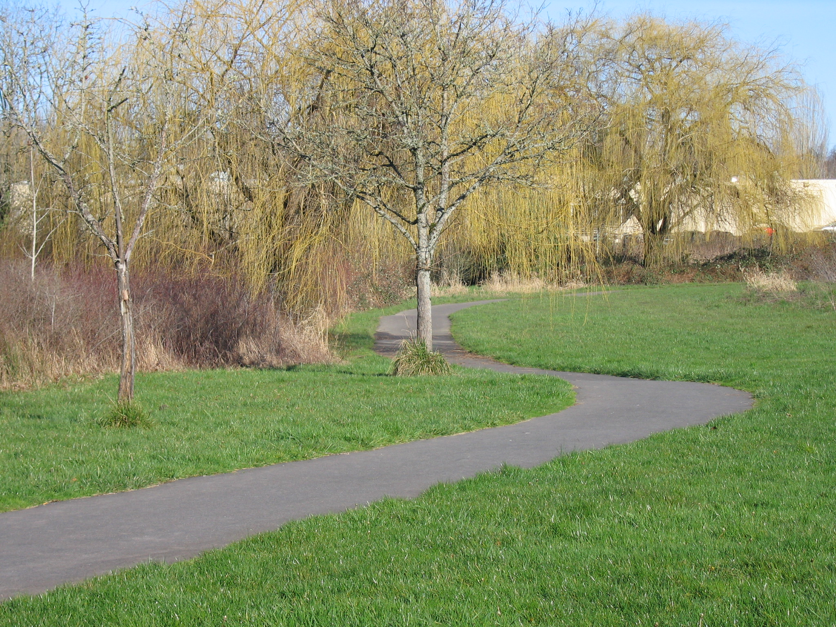
Trails Advisory Committee
Tuesday, May 18, 2010 7:00 PM
Elsie Stuhr Center
The Poplar Room

AGENDA

- Welcome

- Introduction of Guests/Visitors

- Approval of April meeting minutes

- Announcements

- Volunteer hours for April

- Guest Speaker: Safe Routes to Schools Program: Ruth Deal, SRTS Coordinator at West Tualatin View Elementary Ruth

- Grants: State (ODOT) Bike/Ped and Federal Transportation Enhancement Hal

- May 15 Second Annual Regional Trail Ride – Reprise Joe & Mary
- Action: Trails Master Plan Benchmarks Kevin

- June 5 National Trails Day Project: Westside Trail/Murray Hill Power Line Park

- Westside Regional Trail Master Plan Committee Report Joe

- Updates: Metro, Washington County, City of Beaverton, Beaverton School District,
COB Bicycle Advisory Committee

- Park District Re-Naming Project Steve

- BES Community Benefit Funds Project Steve

- Staff Update on Trail Projects Steve
  - Fanno Creek Trail
  - Bond Measure Trails Update
  - Lee’s Memorial Bench
  - Proposed Kiosk Locations (2)

Next Meeting: June 15, 2010: 6PM: Annual TAC Picnic Fanno Farm House
Guests: Family and friends

