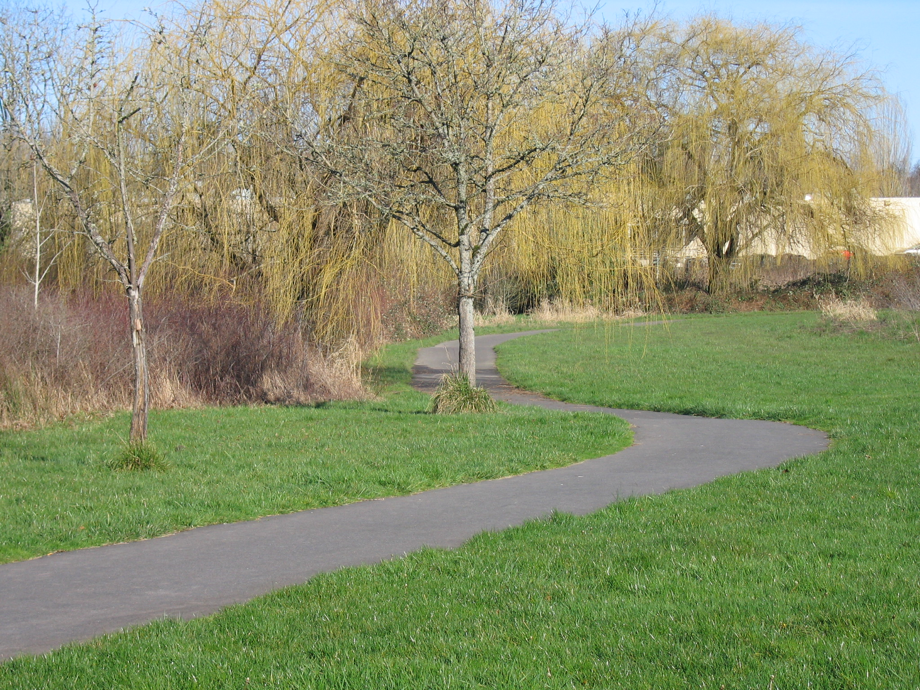
Trails Advisory Committee

Tuesday, February 16, 2010 7:00 PM
Elsie Stuhr Center
The Poplar Room

AGENDA

- Welcome

- Introduction of Guests/Visitors

- A Moment of Remembrance for Lee Ascher

- Approval of December/January meeting minutes

- Announcements

- Volunteer hours for January

- Guest Speaker: Susan Peithman, BTA Statewide Advocate for Safe, Convenient, and Accessible Bicycling: What’s on Oregon’s Horizon?

- Westside Regional Trail Master Plan Committee Report Joe

- Challenge Grant Expenditures - Discussion

- Update: Trails Master Plan Benchmarks Kevin

- District Trail Maps: An Overall Plan - Discussion

- Updates: Metro, Washington County, City of Beaverton, Beaverton School District, COB BAC

- Staff Update on Trail Projects Steve
  - Fanno Creek Trail
  - Bond Measure Trails Update

Next Meeting: March 16, 2010
What Tigard Is Doing With Trails –
Guest Speaker: Duane Roberts, City of Tigard Long Term Planning

