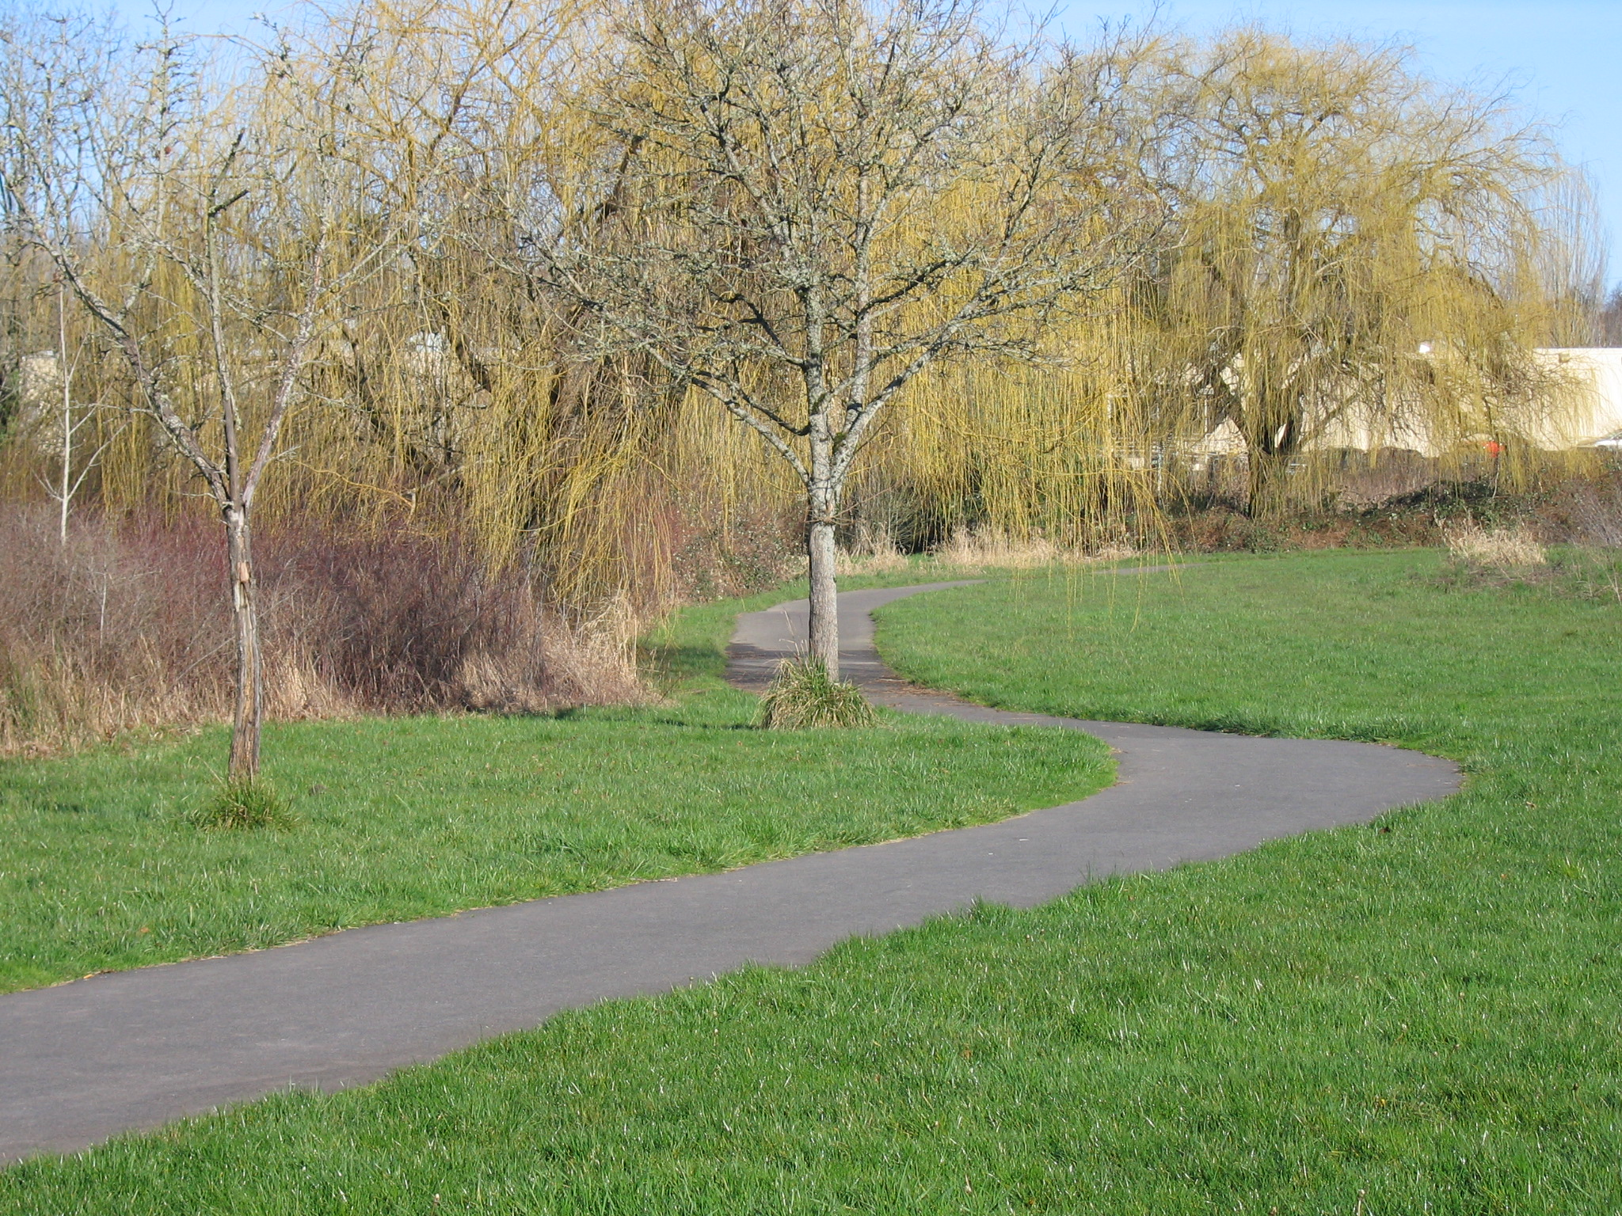
Trails Advisory Committee
Tuesday, February 17, 2012 7:00 PM
Fanno Creek Service Center
Main Conference Room

AGENDA

- Welcome

- Introduction of Guests/Visitors and new committee member

- Approval of January meeting minutes

- Volunteer hours for January

- Eichler Park video

- Announcements:

- 2012 Meeting Calendar/Programs

- 2012 Plan of Action

- Westside Regional Trail Master Plan Committee Report Joe

- TAC Challenge Grant Funds Steve

- Staff Update on Trail Projects Steve

  - Fanno Creek Trail
  - Bond Measure Trails Update
    - Westside Trail
    - Waterhouse Trail
    - Rock Creek/N. Bethany
  - MTIP Funding
    - Fanno Creek Trail/Hall Blvd Feasibility Study
    - Westside Trail Segment #18

- Detailed Updates: Washington County, City of Beaverton, Beaverton School District, COB BAC, Metro

Next Meeting: March 20, 2012, 7:00pm at the Elsie Stuhr Center

