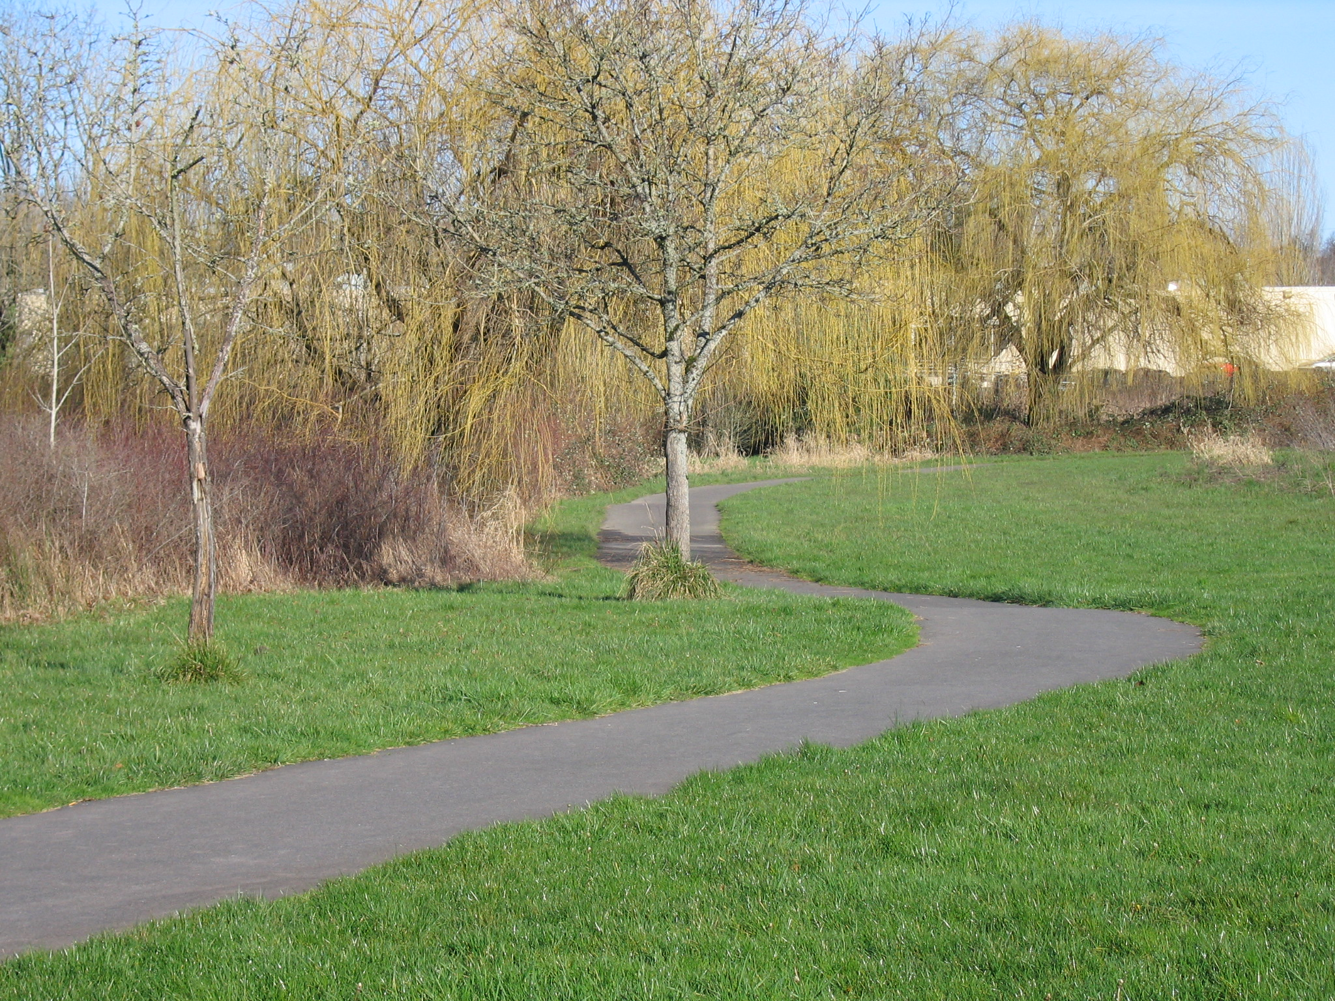
Trails Advisory Committee
Tuesday, May 17, 2011 7:00 PM
Elsie Stuhr Center
The Poplar Room

AGENDA

- Welcome

- Introduction of Guests/Visitors

- Approval of April meeting minutes

- Announcements

- Volunteer hours for April

- Coordination with SW Trails/Portland/Red Electric Trail Tom

- May 14th Third Annual “Ride Into Spring” Trail Ride Joe/Mary

- June 4th National Trails Day Project: Jenkins Estate

- Summer Activity Planning: Trade July Meeting for….

- Westside Regional Trail Master Plan Committee Report Joe

- Updates: Metro, Washington County, City of Beaverton, Beaverton School District, COB BAC

- Staff Update on Trail Projects Steve

  - Lowami Hart Woods Update
  - Fanno Creek Trail
  - Bond Measure Trails Update
  - MTIP Funding
    - Fanno Creek Trail/Hall Blvd Feasibility Study
    - Westside Trail Segment #18
  - Regional Flexible Funding 2014/15 Hal/Steve

Next Meeting: June 21, 2011: Summer Picnic

